**Comparative Analysis on Automated Pothole-Detection Methods**

1. **INTRODUCTION**

A pothole is a hole in a road surface that results from gradual damage caused by a traffic and weather conditions. The general process of pothole detection consists of four steps: data acquisition, data pre-processing, feature extraction, and pothole classification. The pothole classification step determines the existence of potholes by applying a pothole-detection algorithm based on the features.

1. Application - To contribute to the prevention of traffic accidents and the smooth flow of traffic. Identifying and managing potholes in advance plays an important role in securing driver safety and preventing traffic accidents.
2. Focus and purpose**: This paper focuses** the automated pothole-detection methods can be classified into three types according to the technology used in the pothole-recognition process: a vision-based method, YOLO based method, and a CNN based method. In this paper, three methods are compared, and the strengths and weaknesses of each method are summarized.
3. Broad Problem: Designing a pothole detector using machine learning/image processing.

j) Motivation:  The motivation behind the proposed framework lies in the deficiencies of current practice and the potential of gradually and inexpensively converting passenger vehicles into ubiquitous sensors and reporters of the roads’ condition. The work presented in this paper is the first step to achieve our objective. We use a window mounted camera on an equipped passenger vehicle that collects visual pavement data. This data is then used to validate our method for automated pothole detection in pavement images.

k) Linking words: Motivation, Proposed Framework, Mounted camera, Image captured, Automatically Processed, detection.

i) Novelty:  The main novelty resides on the application of latest progress in Artificial Intelligence to learn the visual appearance of potholes. We built a large dataset of images with pothole annotations. They contained road scenes from different cities in the world, taken with different cameras, vehicles and viewpoints under varied environmental conditions

m) Linking words: Novelty, AI, visual appearance, pothole, data, cameras, environmental, conditions.

n) Advantages of the System:

1. Pothole present on the road can be effectively identified.
2. Road maintenance authority gets information and prior knowledge regarding the places where they required for repairs to the road.
3. Cost of identification of pothole is reduced compared with other systems for detections of pothole.

o) Disadvantages of the System:

1. If the vehicle is at very high speed, accuracy of pothole detection may be less.

2. In the rainy season and night, the identification of the pothole on the roads becomes a difficult task.

P) Contents:

|  |  |  |
| --- | --- | --- |
| **S. NO.** | **TITLE** | **PAGE NO.** |
| 1. | Vision and Deep learning-based model | 5 |
| 2. | YOLO based identifying model | 6 |
| 3. | CNN based model | 7 |
| 4. | Conclusion | 8 |

**Models:**

1. Vision and Deep learning-based model:

The proposed method consisted of proposed method consists of two processes: pothole detection and pothole segmentation. In the process of pothole detection, the wavelet energy field of the asphalt image was constructed by morphological processing and geometric criteria. The detected pothole was segmented via Markov random field model and the pothole edge was extracted accurately. The contours within the frame that describe the specific road colour sections are then determined.

Source Code: Please see the attached file.

1. YOLO based identifying model:

The images in training subset were converted to a format size of 416*416 pixels to meet the input requirement for the chosen architecture.

The sequence of actions to perform tasks in order to detect potholes in the road surface.

* In the ﬁrst step, a pothole dataset was collected from the previous research and the various YOLO models were reconstructed to be suitable for the tasks of pothole detection.
* Next, the models were trained and validated until the loss function reached a steady-state line, which the average loss insigniﬁcant changed.
* The quality of object detection, which requires to draw a bounding box around each detected object in the image, was conﬁrmed by evaluating the performance of an object detector using three metrics (i.e., precision, recall, and mAP) as shown in Equations (1)–(3) .

#PRECISION = TP/TP+FP -------(1)

#RECALL =TP/TP+FN ---------(2)

n

mAP = 1/n ∑APi

i=1

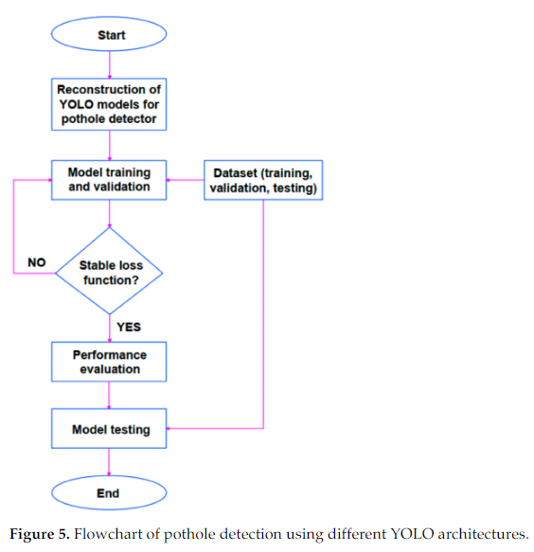

Source Code: Please see the attached file.

1. CNN based model:

collecting the pothole data in different Indian trafﬁc conditions and detecting of the same using a vision-based method by deﬁning the performance of deep learning methods like sequential convolutional neural network (CNN).The experiments were conducted on CNN model and a conclusion was drawn to bring out the beneﬁts of the model with 94% accuracy.

In this paper we have used 224*224 size image dataset to meet input requirements of VGG16 architecture.

Source Code: Please see the attached file.

**Accuracies**

1. Vision and Deep learning-based model:

|  |
| --- |
| Accuracy rate **- Pothole: 96.03%** |
| - Bump: 94.12% |

1. YOLO based identifying model:

|  |
| --- |
| 1.**YOLOv4** achieved a high recall of **81%**, high precision |
| of **85%** and **85.39%** mean Average Precision (mAP). |

1. CNN based model:

Linear SVM achieved accuracy rate of **96.43%**.

* ACKNOWLEDGEMENT

The authors would like to thank MTN for their continued financial support through the MTN Mobile Intelligence Lab.

* REFERENCE

CSIR, 2010. Potholes: Technical guide to their causes, identification and repair.

Available at: http://www.csir.co.za/pothole_guides/docs/Pothole_CSIR_tech_guide.pdf

Danti, A., Kulkarni, J. & Hiremath, P., 2012. An Image Processing Approach to Detect Lanes, Pot Holes and Recognize Road Signs in Indian Roads. International Journal of Modeling and Optimization, 2(6), pp. 658-662